|  |
| --- |
| **North South University**  Department of Electrical & Computer Engineering  **LAB REPORT-8**  Course Code: CSE231L  Course Title: Digital Logic Design  Section: 8  Experiment Number: 8  Experiment Name:  Synchronous Sequential Circuits  Experiment Date: 21/8/2021  Date of Submission: 30/8/2021  Submitted By: Md. Rifat Ahmed - 1931725042  Course Instructor: Md. Shahriar Hussain  Submitted To: Md. Anisur Rahman Asif |

**Objectives:**

* Our first objective is to gain a practical understanding of State Diagrams and State Tables.
* Then we have to understand the concept of designing Sequential Circuits using Flip-Flops.
* And then, we have to design and implement a Synchronous Sequential Circuit using the given State Diagram.

**Apparatus:**

**Experiment 1:**

* 1 x IC 74107 JK Flip-Flop
* 1 x IC 7408 2-input AND gates
* 1 x IC 7404 Hex Inverter (NOT gates)
* Trainer Board
* Wires

**Experiment 2:**

* 1 x IC 74107 JK Flip-Flop
* 1 x IC 7408 2-input AND gates
* 1 x IC 7432 2-input OR gates
* 1 x IC 7404 Hex Inverter (NOT gates)
* Trainer Board
* Wires

**Experiment 3:**

* 1 x IC 7474 Dual D Flip-Flops
* 1 x IC 7408 2-input AND gates
* 1 x IC 7432 2-input OR gates
* 1 x IC 7404 Hex Inverter (NOT gates)
* Trainer Board
* Wires

**Theory:**

**Sequential Circuits:**

A sequential circuit is made up of 2 parts, a combinational circuit and a memory device like flip-flop or registers which is connected to the combinational circuit. In a sequential circuit the binary information stored at any given time is called its present state and for a predefined set of inputs and the present state it’ll have a next state unlike combinational circuits which only rely on the present input values.

And a synchronous sequential circuit is a system which has all its memory device connected to common clock so when a pulse is given it affects all the memory devices in the circuit.

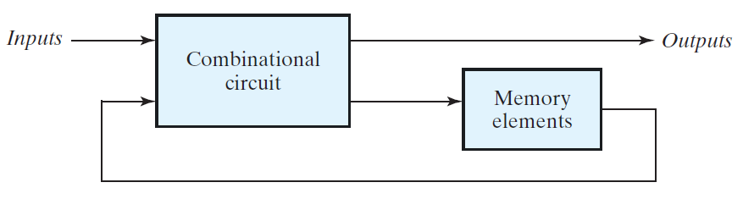

Figure: Synchronous Sequential Circuit

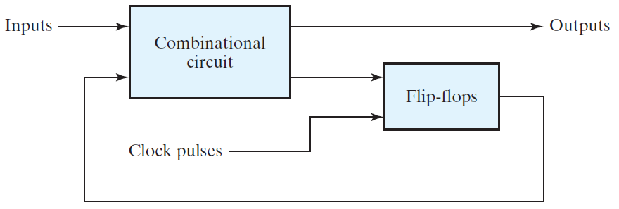But in an asynchronous sequential circuit the memory devices don’t have a common clock rather they can depend on any given time or order according to which the inputs change.

Figure: Asynchronous Sequential Circuit

**Experimental Procedure:**

**Experiment 1:**

To begin the experiment, we have to fill out Table 1 where we have to write the present state, input, next state and output from the given state diagram. Then we have to use the Excitation table of JK flip-flop and find out the values of JA, KA, JB, KB ­using the present state and next state values. Then we have to minimize the input-output functions using Kmap and then build a sequential circuit in Logisim using them and verify out results with Table 1.

**Experiment 2:**

Then for the 2nd experiment we again have to write the present state, input, next state and output from the given state diagram in Table 2. Then we have to use the Excitation table of T flip-flop and find out the values of TA, TB ­using the present state and next state values. Then we have to minimize the input-output functions using Kmap and build another sequential circuit in Logisim using JK flip-flops but converting them into T flip-flops by connecting J into K and verify our results with Table 2.

**Experiment 3:**

Finally, for the last experiment, we once again have to write the present state, input, next state and output from the given state diagram in Table 3. Then we have to use the Excitation table of D flip-flop and find out the values of DA, DB ­using the present state and next state values. Then we have to minimize the input-output functions using Kmap and build one more sequential circuit in Logisim using D flip-flops and verify our results with Table 3.

**Question/Answer:**

**Answer to the Question No. 1 of Experiment 2:**

The output equation (Y) of this circuit is the same as the equation in the JK Flip-Flop circuit of our first experiment. And that’s because we used the same state diagram for all of our experiments. So, as we used the same state diagram for different types of flips flops so it only affected our input functions but the output remained same as it was given in the state diagram.

**Answer to the Question No. 1 of Experiment 3:**

Drawing the IC diagram for the logic circuit of Experiment 3:

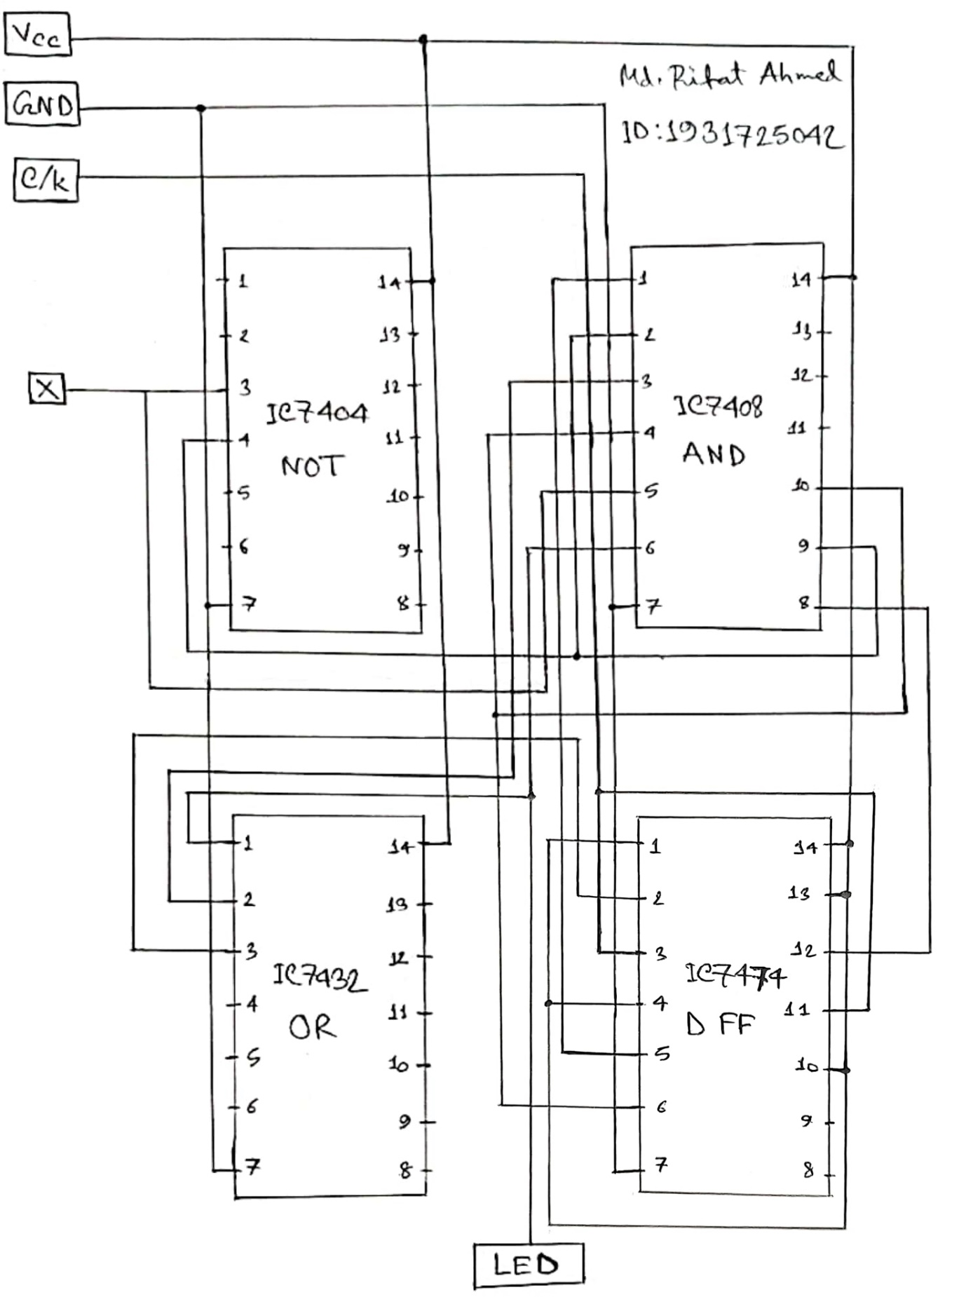

**Discussion:**

Through this lab we have learned mainly about synchronous sequential circuits. At the beginning we learned about how a sequential circuit functions then we learned about state diagrams, state table, and how to get the input-output equations from the state table and then how to draw the sequential circuit using those equations in Logisim. In the 1st experiment we constructed a sequential circuit using JK flip-flop from the given state diagram. We had to complete the state table using the values from the state diagram however, there might have been some error in the Output values given in the diagram because when built the circuit using the input-output equations for the given inputs we weren’t getting the same output which clearly indicates some error in the values. Then in the 2nd experiment we constructed another circuit using the same state diagram but this time we used T flip-flops and for the 3rd and final experiment we used D flip-flops for the same state diagram. So overall, in this experiment we learnt a major topic but as there was an error in the given output values, we couldn’t verify our circuits that’s the only problem we had to face during this experiment.

**Data Sheet & Circuit Diagrams:**

**Data of Experiment 1: Constructing a Sequential Circuit using JK Flip-Flops**

|  |  |  |  |  |  |  |  |  |  |
| --- | --- | --- | --- | --- | --- | --- | --- | --- | --- |
| **Present state** | | **Input** | **Next state** | | **Output** | **Flip-flop input functions** | | | |
| **A** | **B** | **X** | **A** | **B** | **Y** | **JA** | **KA** | **JB** | **KB** |
| 0 | 0 | 0 | 0 | 1 | 0 | 0 | X | 1 | X |
| 0 | 0 | 1 | 1 | 0 | 1 | 1 | X | 0 | X |
| 0 | 1 | 0 | 0 | 1 | 0 | 0 | X | X | 0 |
| 0 | 1 | 1 | 1 | 0 | 1 | 1 | X | X | 1 |
| 1 | 0 | 0 | 1 | 0 | 0 | X | 0 | 0 | X |
| 1 | 0 | 1 | 0 | 0 | 0 | X | 1 | 0 | X |
| 1 | 1 | 0 | X | X | X | X | X | X | X |
| 1 | 1 | 1 | X | X | X | X | X | X | X |

**Table 1:** State Table for circuit using JK Flip-Flops

|  |  |  |  |  |  |  |  |  |  |  |  |  |  |  |  |  |
| --- | --- | --- | --- | --- | --- | --- | --- | --- | --- | --- | --- | --- | --- | --- | --- | --- |
| 0 | 1 | 1 | 0 |  |  | X | X | X | X |  |  | 1 | 0 | X | X |  |
| X | X | X | X |  |  | 0 | 1 | X | X |  |  | 0 | 0 | X | X |  |

**JA = X**

**JB = A’X’**

**KA = X**

|  |  |  |  |  |  |  |  |  |  |
| --- | --- | --- | --- | --- | --- | --- | --- | --- | --- |
| X | X | 1 | 0 |  |  | 0 | 1 | 1 | 0 |
| X | X | X | X |  |  | 0 | 0 | X | X |

**Y = A’X**

**KB = X**

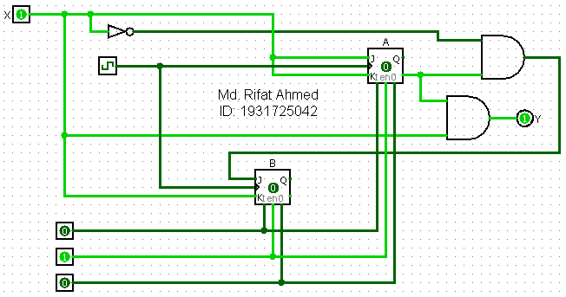

**Figure 1:** Circuit Diagram

**Data of Experiment 2: Constructing a Sequential Circuit using T Flip-Flops**

|  |  |  |  |  |  |  |  |
| --- | --- | --- | --- | --- | --- | --- | --- |
| **Present state** | | **Input** | **Next state** | | **Output** | **Flip-flop input functions** | |
| **A** | **B** | **X** | **A** | **B** | **Y** | **TA** | **TB** |
| 0 | 0 | 0 | 0 | 1 | 0 | 0 | 1 |
| 0 | 0 | 1 | 1 | 0 | 1 | 1 | 0 |
| 0 | 1 | 0 | 0 | 1 | 0 | 0 | 0 |
| 0 | 1 | 1 | 1 | 0 | 1 | 1 | 1 |
| 1 | 0 | 0 | 1 | 0 | 0 | 0 | 0 |
| 1 | 0 | 1 | 0 | 0 | 0 | 1 | 0 |
| 1 | 1 | 0 | X | X | X | X | X |
| 1 | 1 | 1 | X | X | X | X | X |

**Table 2:** State Table for circuit using T Flip-Flops

|  |  |  |  |  |  |  |  |  |  |  |  |  |  |  |  |  |
| --- | --- | --- | --- | --- | --- | --- | --- | --- | --- | --- | --- | --- | --- | --- | --- | --- |
| 0 | 1 | 1 | 0 |  |  | 1 | 0 | 1 | 0 |  |  | 0 | 1 | 1 | 0 |  |
| 0 | 1 | X | X |  |  | 0 | 0 | X | X |  |  | 0 | 0 | X | X |  |

**TB = BX + A’B’X’**

**Y = A’X**

**TA = X**

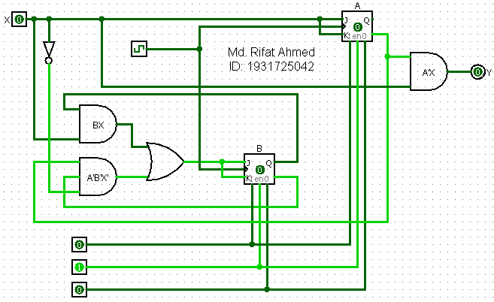

**Figure 2:** Circuit Diagram

**Data of Experiment 3: Constructing a Sequential Circuit using D Flip-Flops**

|  |  |  |  |  |  |  |  |
| --- | --- | --- | --- | --- | --- | --- | --- |
| **Present state** | | **Input** | **Next state** | | **Output** | **Flip-flop input functions** | |
| **A** | **B** | **X** | **A** | **B** | **Y** | **DA** | **DB** |
| 0 | 0 | 0 | 0 | 1 | 0 | 0 | 1 |
| 0 | 0 | 1 | 1 | 0 | 1 | 1 | 0 |
| 0 | 1 | 0 | 0 | 1 | 0 | 0 | 1 |
| 0 | 1 | 1 | 1 | 0 | 1 | 1 | 0 |
| 1 | 0 | 0 | 1 | 0 | 0 | 1 | 0 |
| 1 | 0 | 1 | 0 | 0 | 0 | 0 | 0 |
| 1 | 1 | 0 | X | X | X | X | X |
| 1 | 1 | 1 | X | X | X | X | X |

**Table 3:** State Table for circuit using D Flip-Flops

|  |  |  |  |  |  |  |  |  |  |  |  |  |  |  |  |  |
| --- | --- | --- | --- | --- | --- | --- | --- | --- | --- | --- | --- | --- | --- | --- | --- | --- |
| 0 | 1 | 1 | 0 |  |  | 1 | 0 | 0 | 1 |  |  | 0 | 1 | 1 | 0 |  |
| 1 | 0 | X | X |  |  | 0 | 0 | X | X |  |  | 0 | 0 | X | X |  |

**Y = A’X**

**DA = AX’ + A’X**

**DB = A’X’**

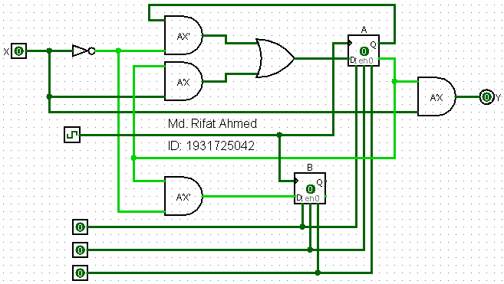

**Figure 3:** Circuit Diagram

**Simulation:**

Simulating Experiment 1:

